Directions: Write the nuclear decay equation for your group’s scenario.
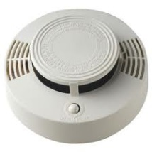
1. A battery-operated smoke detector produces an alarming sound when its electrical sensor detects smoke particles. Some ionizing smoke detectors contain the radioisotope americium-241, which undergoes alpha decay and has a half-life of 433 years. The emitted alpha particles ionize gas molecules in the air. As a result, an electric current flows through the detector. When smoke particles enter the detector, the flow of ions is interrupted, causing the alarm to sound.
Decay equation:

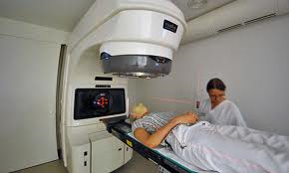
2. A new form of chemotheraphy known as TAT (targeted alpha therapy) uses a carrier molecule to transport lead-212 to the site of the tumor. Once lead-212 reaches the tumor, the radioactive nucleus undergoes alpha decay. The alpha particles produce kills tumor cells. One risk of chemotherapy is the side effects due to the alpha particles affecting perfectly healthy cells.

Decay equation:

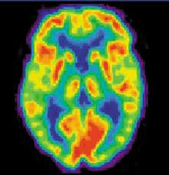
3. A PET (Positron emission tomography) scan is a nuclear medicine imaging technique that detects the positron emission of a radioactive isotope known as a tracer. Doctors inject a radioactive isotope tracer such as nitrogen-13 into the blood stream. As the nitrogen-13 travels throughout your body, the PET machine detects the positrons that are released as N-13 decays in the blood stream. Using the detection pattern, a PET scan produces images of processes in your body. One drawback of PET scans is that it does expose patients to a significant amount of radiation and therefore there needs to be significant justification for a PET scan.
Decay equation:

4. On April 26, 1986 at 1:23 am, an explosion occurred in Reactor Number 4 of the Chernobyl Nuclear Power Plant in Ukraine. The radioactive particles rained down not only on Chernobyl, but all over Ukraine, as well as the neighboring countries of Belarus and Russia, and other European countries such as Poland. Scientists estimate that the amount of particles released was equivalent to the effect of 20 nuclear bombs. The massive radiation killed 31 people within a short time. As time passed, it became clear that the accident had left a number of serious long-term health problems for people who lived in the area. One of the long-term medical side effects were an increase in thyroid cancer caused by the radioactive isotope I-131, which mutates cells in the thyroid, where normal iodine-127 is absorbed.
Decay equation:

5. Food irradiation is a technology used for controlling food spoilage and eliminating food-borne pathogens, such as salmonella. Cesium-137 is commonly used by exposing food to low doses of radioactive particles, which then mutates the DNA of the pathogens beyond repair. Food irradiation does not make food radioactive, it just damages the DNA of any living pathogens that may be responsible for food-borne illnesses and spoilage. All foods that have undergone food irradiation is marked with a sign that looks like the one below.
Decay equation:

6. Emergency exit signs stay lit up even after the electricity has gone off. This is possible due to a process called radioluminescence (think: glow-in-the-dark stickers). Glow-in-dark technology is simply due to tritium, hydrogen-3, which undergoes beta decay and produces an electron. When the electron is released, it produces light that does not need an external power source to stay illuminated.

Decay equation:

